***Do the below programs in anonymous function & IIFE***

**1. Print odd numbers in an array:**

const first_program = function(a) {

for(let i = 0;i<a.length;i++)

if(a[i]%2 != 0) console.log(a[i]);}

let a = [1,2,3,4,5,6,7,8,9,10];

first_program(a);

**Output:**

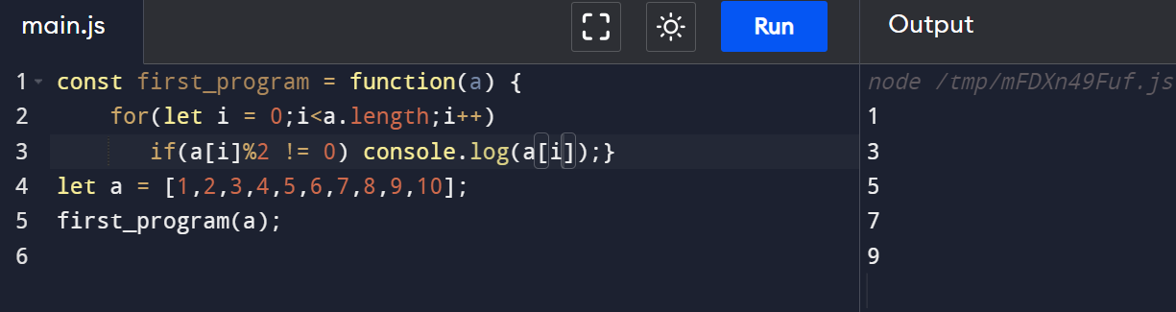

**2. Convert all the strings to title caps in a string array.**

const second_program = function (a,b){

for(let i = 0;i<a.length;i++)

b.push(a[i].charAt(0).toUpperCase()

+ a[i].slice(1,a[i].length));

return b;

}

let a = ["john","peter","tom"], b = [];

console.log(second_program(a,b));

**Output:**

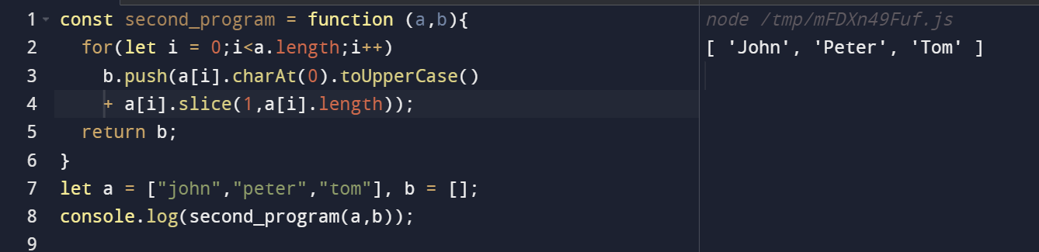

**3. Sum of all numbers in an array**

let thrid_program = function (a,b) {

for(let i = 0;i<a.length;i++) b+=a[i];

return b;

}

let a = [10,20,30,40,50], b = 0;

console.log(thrid_program(a,b));

**Output:**

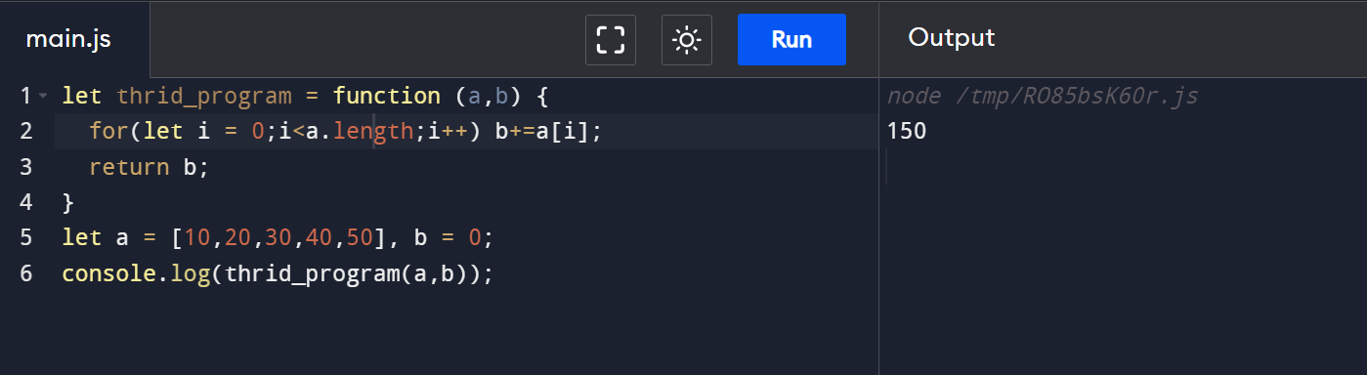

**4.Return all the prime numbers in an array**

let fourth_program = function (a,b) {

for(let i = 0;i<=a.length;i++){

let val = 0;

for(let j = 1;j<=a[i];j++)

if(a[i]%j == 0) val++;

if (val == 2) b.push(a[i]);

}

return b;

}

let a = [55,44,3,10,2,4,7,9,19,13], b = [];

console.log(fourth_program(a , b));

**Output:**

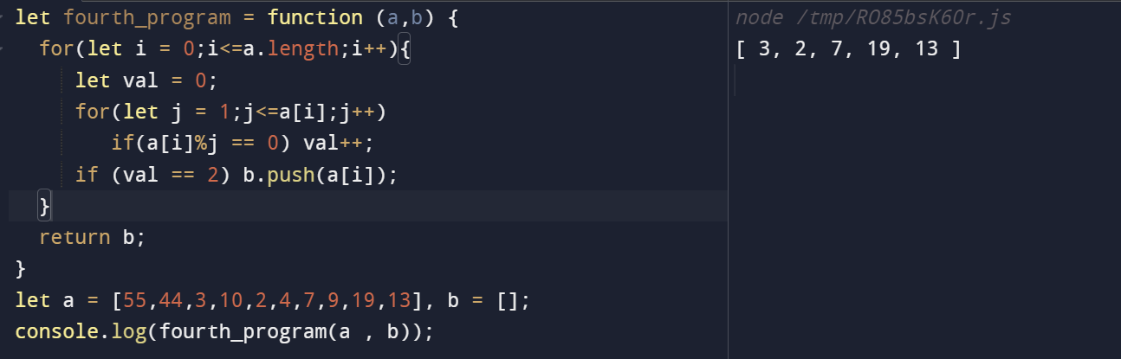

**5. Return median of two sorted arrays of the same size.**

const fifth_problem = function(a1,a2) {

for(let i = 0;i< a1.length;i++){

output.push(a1[i])

if(i < a2.length) output.push(a2[i])

}

let val = output.sort(function(a , b){return a - b})

return Math.floor((val[Math.floor((val.length)/2)] +

val[Math.floor((val.length/2) - 1)])/2);

}

const a1 = [1,12,15,26,38],a2 = [2,13,17,30,45], output=[]

console.log(fifth_problem(a1,a2));

**Output:**

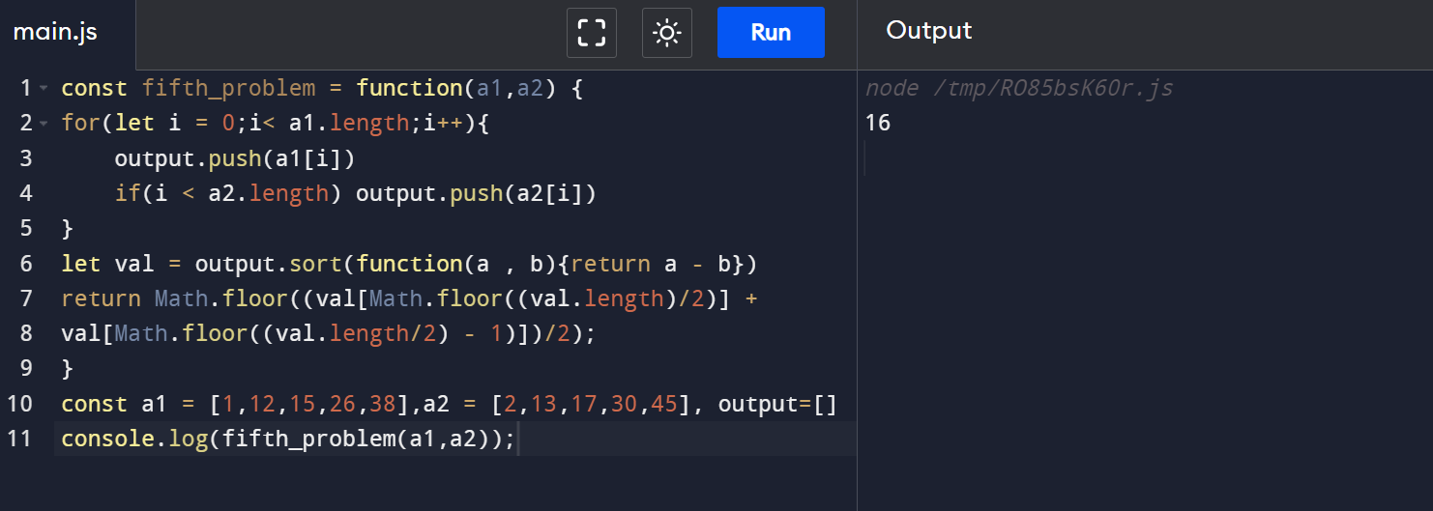

**6.** **Remove duplicates from an array.**

const sixth_program = function() { for(let i=0;i<a.length;i++) if(!b.includes(a[i])) b.push(a[i]);}

const a = ["peter","peter","peter","tom"],b = [];

sixth_program(a,b)

console.log(b)

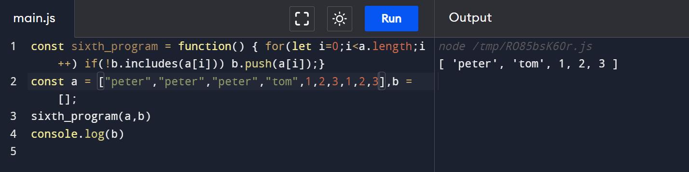

**7. Rotate an array by k times**

const seveth_function = function(a,b,k,j){

for(let i = 0;i<a.length;i++){

if (i > a.length-1- k){

b.splice(j,0,a[i]);

j++;

}

else b.push(a[i]);

}

}

let a = [ 4, 5, 6, 3, 1], b = [],k = 2,j=0;

seveth_function(a,b,k,j);

console.log(b);

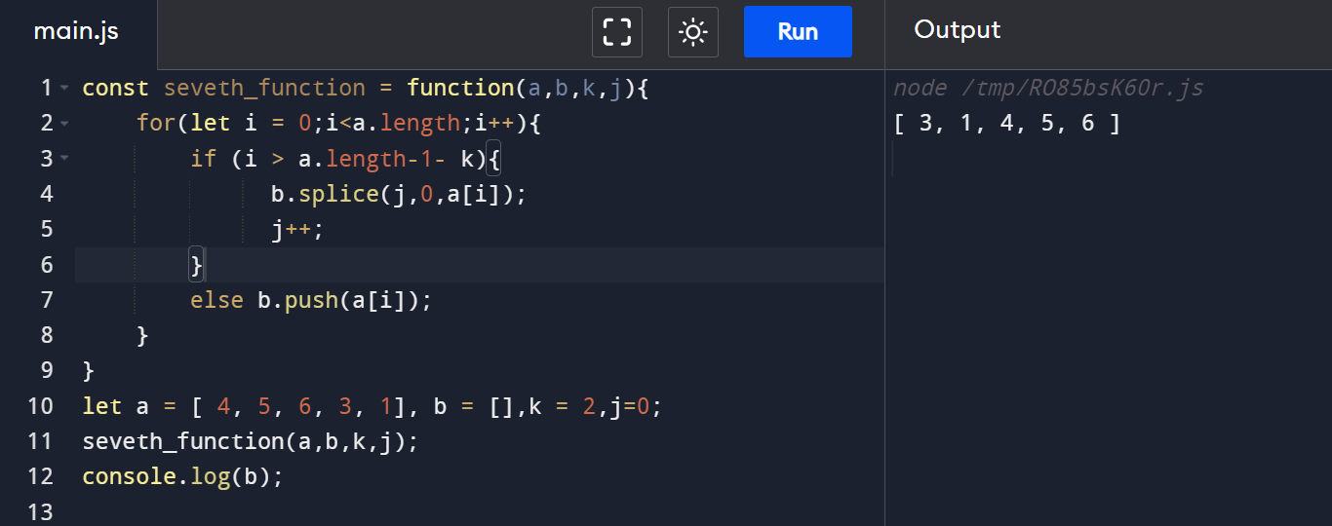

**8.** **Return all the palindromes in an array.**

const seventh_program = function (a,b) {

for(let i = 0; i< a.length;i++){

let c = ""

for(let j = a[i].length - 1;j>=0;j--) c+=a[i][j]

if (a[i] == c) b.push(c)

}

}

let a = ["mam","madam","yes","okay","are"], b = []

seventh_program(a,b)

console.log(b)

**Output:**

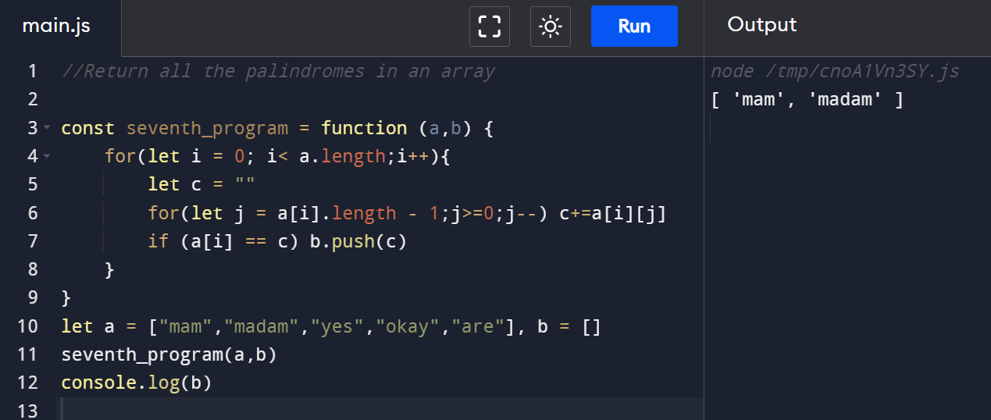

***Do the below programs in arrow functions***.

**1.** **Print odd numbers in an array**

const first_program = (a) => { for(let i = 0;i<a.length;i++) if(a[i]%2 != 0) console.log(a[i]); }

let a = [1,2,3,4,5,6,7,8,9,10];

first_program(a);

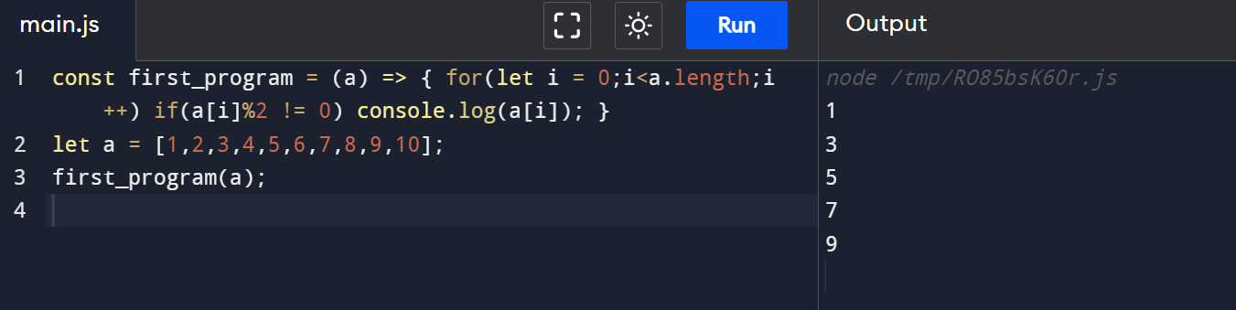

**2.** **Convert all the strings to title caps in a string array**

const second_program = (a,b) =>{

for(let i = 0;i<a.length;i++)

b.push(a[i].charAt(0).toUpperCase() + a[i].slice(1,a[i].length));

return b;

}

let a = ["john","peter","tom"], b = [];

console.log(second_program(a,b));

**Output:**

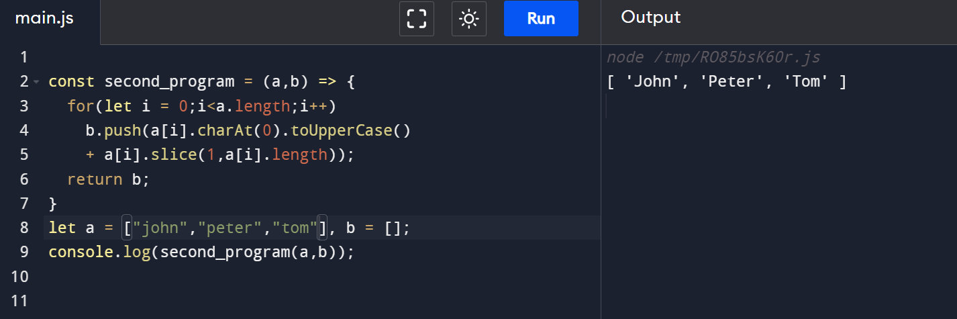

**3. Sum of all numbers in an array**

const thrid_program = (a,b) => { for(let i = 0;i<a.length;i++) b+=a[i]; return b;

}

let a = [10,20,30,40,50], b = 0;

console.log(thrid_program(a,b));

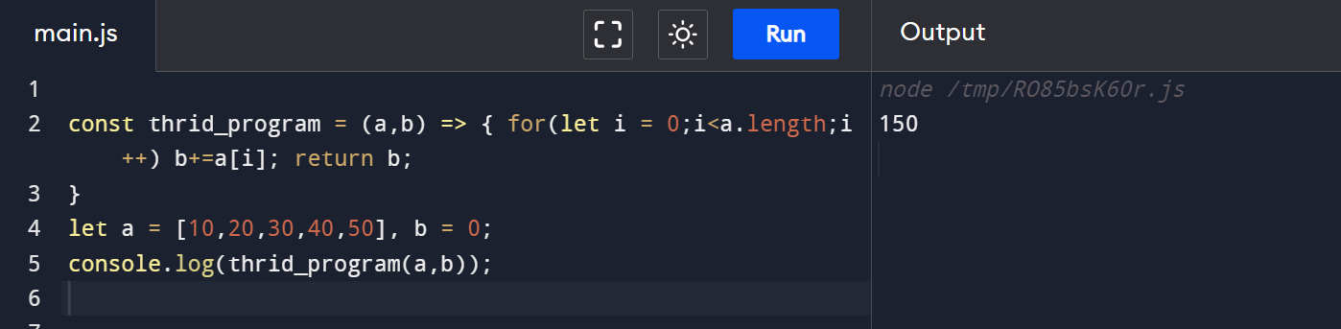

**4.** **Return all the prime numbers in an array**

let fourth_program = (a,b) => {

for(let i = 0;i<=a.length;i++){

let val = 0;

for(let j = 1;j<=a[i];j++)

if(a[i]%j == 0) val++;

if (val == 2) b.push(a[i]);

}

return b;

}

let a = [55,44,3,10,2,4,7,9,19,13], b = [];

console.log(fourth_program(a , b));

**Output:**

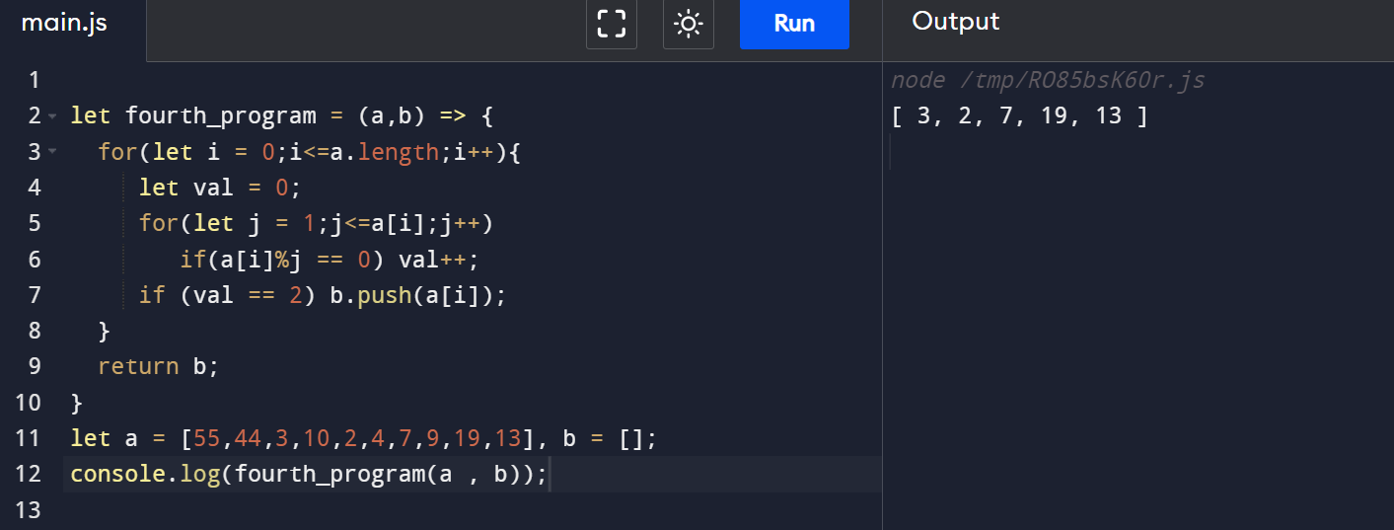

**5.** **Return all the palindromes in an array**

const seventh_program = (a,b) => {

for(let i = 0; i< a.length;i++){

let c = ""

for(let j = a[i].length - 1;j>=0;j--) c+=a[i][j]

if (a[i] == c) b.push(c)

}

}

let a = ["mam","madam","yes","okay","are"], b = []

seventh_program(a,b)

console.log(b)

**Output:**

